EXPERIMENT 1 — Create a Kanban Board in Jira AIM
To create a Kanban board in Jira to visualize tasks and demonstrate the workflow using To Do, In Progress, and Done columns.

PROCEDURE
- Logged in to Jira using an Atlassian account.
- Created a Kanban project named Food Delivery App.
- Configured the board with the columns Backlog, To Do, In Progress, and Done.
- Created five sample tasks:
  - Design Login Page
  - Create User Registration
  - Develop Food Menu
  - Implement Payment Module
  - Test Food Ordering
- Added the tasks to the board and arranged them in the To Do column.
- Dragged the tasks from To Do to In Progress to represent ongoing work.
- Moved the completed tasks from In Progress to Done.
- Observed the task workflow using the Kanban board.

SCREENSHOTS
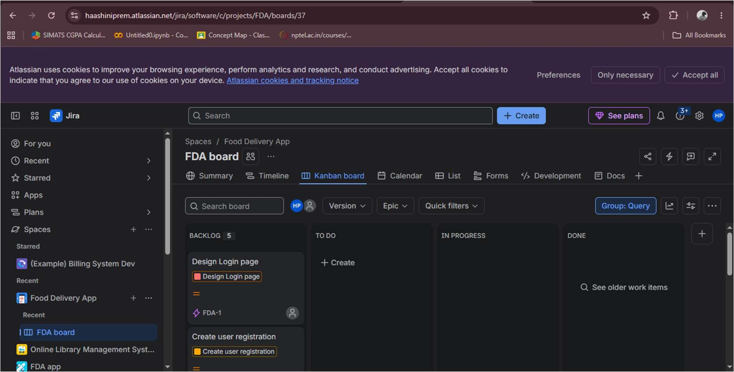
Screenshot 1: Kanban board displaying the five sample tasks.
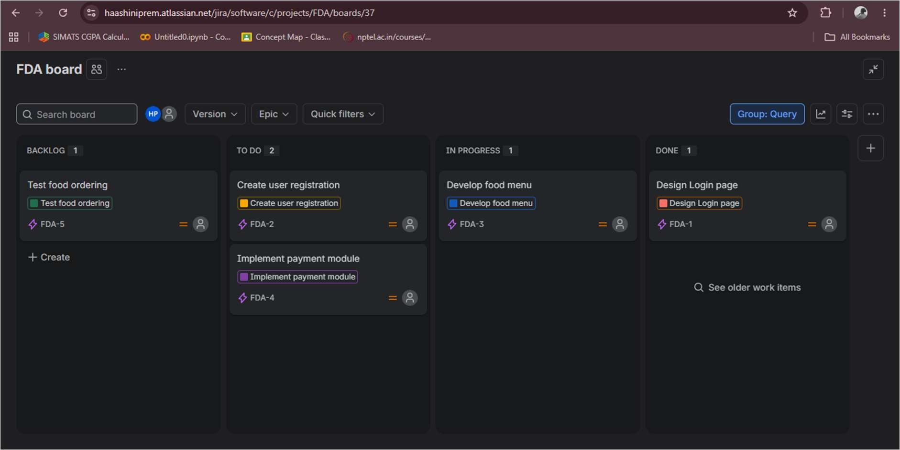
Screenshot 2: Kanban board showing tasks moved between To Do, In Progress, and Done.

OUTPUT
A Kanban board was created successfully in Jira with five sample tasks, and the movement of tasks across the workflow columns was demonstrated.

RESULT
Thus, a Kanban board was successfully created and used to visualize and manage the workflow of tasks in Jira.

